1. Change on going projects to projects
2. Transfer news and events to licence and certificates
3. in experiences remove (ksa and Malabo )
4. Insert logos into our client’s section (attached to mail in a we transfer link)
5. Take all data you need for projects from (ongoing projects/section) from pre- qualification attached in we transfer link
6. Remove this section from home page:
7. Insert this data in this section

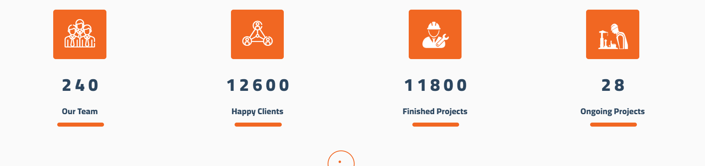

Our team = 100

Happy clients = +200

Finished projects = +500

On going projects = 14

1. Experiences / Egypt projects / (data inside projects are wrong)

Check every project with its right data.

1. Make experience projects icon like this one and projects photos attached in pre-qualification

